
Yunnan University Software College
Professional Training(Intermediate level)
Mid-term report
School of Software, Yunnan University

个人成绩
序号 | 学号 | 姓名 | 成绩
1. | 20233120018 | HAQUE KAZI SHIMANTO

学期: Fall semester 2025
课程名称: Professional Training(Intermediate level)
任课教师: Ahmed Zahir
报告题目: SENTIMENT ANALYSIS SYSTEM USING DISTILBERT AND FAISS VECTOR DATABASE
姓 名: HAQUE KAZI SHIMANTO
联系电话:13116218659
电子邮件:kazishimant069@gmail.com

作业截止时间：2025年12月11日

Abstract:
This project implements an automated sentiment analysis system that combines transformer-based deep learning models with efficient vector database technology. The system utilizes DistilBERT, a lightweight transformer architecture, for sentiment classification and embedding generation, demonstrating the application of deep learning principles in natural language processing. FAISS (Facebook AI Similarity Search) serves as the vector database for semantic similarity search capabilities, enabling efficient storage and retrieval of text embeddings. The application features a dual-layer architecture comprising a FastAPI REST API backend and an interactive Gradio web interface. The entire system is containerized using Docker and orchestrated with Docker Compose, demonstrating modern MLOps practices. Key achievements include real-time sentiment analysis with high accuracy, semantic search functionality, and production-ready deployment pipeline. This project showcases the integration of deep learning, NLP preprocessing, vector databases, and containerization technologies to create a scalable sentiment analysis solution that addresses challenges in automated machine learning pipeline synthesis.

Keywords: Sentiment Analysis, Transformers, DistilBERT, FAISS, Vector Database, Docker, Deep Learning, Natural Language Processing

checking if the word doc file works

1. Introduction

1.1 Motivation for Sentiment Analysis
Sentiment analysis has emerged as an essential technique in the digital era, helping organizations interpret customer opinions, track public perception, and support informed decision-making. As noted in the semantic analysis survey [3], semantic analysis in natural language processing focuses on understanding and representing the meaning of human language to uncover attitudes and opinions expressed in text.

The increasing adoption of sentiment analysis is largely due to its advantages over traditional manual methods. Computer-assisted sentiment analysis can process large amounts of qualitative data more quickly and consistently, while still producing results that are comparable to human coding. This efficiency makes it especially valuable for applications that require timely and scalable analysis of customer feedback, social media content, and other text-based data sources.

1.2 Machine Learning and Deep Learning Background
Machine learning has revolutionized natural language processing by enabling systems to learn patterns from data rather than relying on manually crafted rules. Deep learning, a subset of machine learning based on artificial neural networks, has dramatically advanced the state-of-the-art in NLP tasks. For many applications, deep learning models outperform shallow machine learning models and traditional data analysis approaches [1].

1.3 Significance of Transformers and Vector Databases
Transformer-based models such as BERT (Bidirectional Encoder Representations from Transformers) have established new performance standards across a wide range of NLP tasks. Despite their effectiveness, these models typically require substantial computational resources, which can limit their practicality in real-world deployments. DistilBERT offers a solution by applying knowledge distillation to reduce the model size and number of parameters while preserving much of BERT’s performance [4].

Vector databases serve as an important complement to transformer models by enabling efficient storage, indexing, and retrieval of embedding vectors. These capabilities support semantic search, similarity matching, and other embedding-based operations that are crucial for modern NLP applications. Additionally, automated machine learning frameworks such as AlphaD3M [2] demonstrate how automated pipeline generation can further optimize the integration and performance of transformer models and vector database systems in applied settings.

1.4 Project Objectives
This project aims to develop a comprehensive sentiment analysis system that integrates modern transformer-based deep learning architectures with efficient vector database technology for semantic similarity search. The primary objective is to implement a robust sentiment analysis pipeline utilizing the DistilBERT transformer model, which provides an optimal balance between computational efficiency and classification accuracy. The system will incorporate FAISS (Facebook AI Similarity Search) as the vector database component, enabling efficient storage, indexing, and retrieval of text embeddings for semantic search capabilities. To ensure practical usability and accessibility, the project will develop a user-friendly dual-interface approach featuring both a RESTful API through FastAPI for programmatic access and an interactive web interface using Gradio for intuitive user interaction. Furthermore, the entire application will be containerized using Docker to guarantee reproducibility and ease of deployment across different environments, while Docker Compose will orchestrate the multi-service architecture. Ultimately, this project seeks to demonstrate end-to-end machine learning pipeline deployment best practices, showcasing the complete workflow from data preprocessing and model inference to vector storage and user interface delivery within a production-ready, scalable system.

4. Literature Review

4.1 Semantic Search system
The semantic analysis survey provides a comprehensive overview of semantic analysis approaches, highlighting that semantics is a branch of linguistics investigating language meaning[3]. Early sentiment analysis systems relied on lexicon-based approaches and machine learning classifiers. The introduction of word embeddings enabled better semantic representation, while the transformer revolution began with the attention mechanism, leading to models like BERT which achieved state-of-the-art results on multiple NLP benchmarks [4].

Data preprocessing workflow
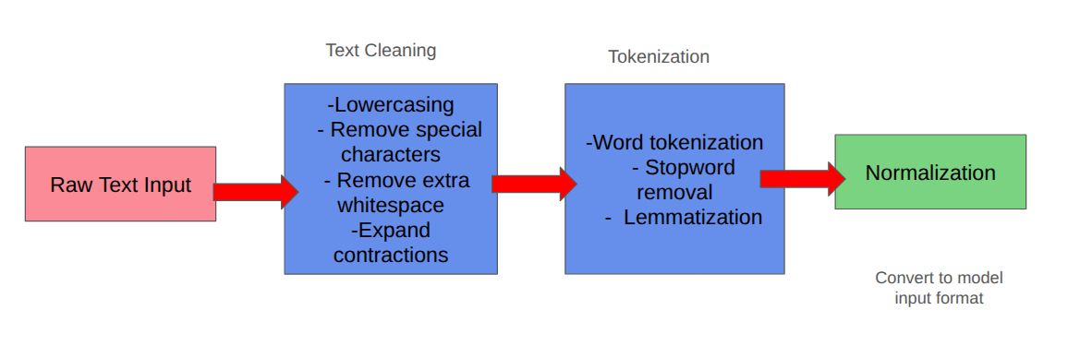

References:
[1] C. Janiesch, P. Zschech, and K. Heinrich, "Machine learning and deep learning," Electronic Markets, vol. 31, pp. 685–695, 2021.
[2] I. Drori et al., "AlphaD3M: Machine Learning Pipeline Synthesis," arXiv preprint arXiv:2111.02508, 2021.
[3] S. A. Salloum, R. Khan, and K. Shaalan, "A Survey of Semantic Analysis Approaches," in Proceedings of the International Conference on Advanced Intelligent Systems and Informatics, pp. 61–72, 2020.
[4] J. Devlin, M.-W. Chang, K. Lee, and K. Toutanova, "BERT: Pre-training of deep bidirectional transformers for language understanding," arXiv preprint arXiv:1810.04805, 2018.
[5] V. Sanh, L. Debut, J. Chaumond, and T. Wolf, "DistilBERT, a distilled version of BERT: smaller, faster, cheaper and lighter," arXiv preprint arXiv:1910.01108, 2019.
[6] M. Johnson, J. Douze, and H. Jégou, "Billion-scale similarity search with GPUs," IEEE Transactions on Big Data, vol. 7, no. 3, pp. 535–547, 2021.
[7] A. Vaswani et al., "Attention is all you need," in Advances in Neural Information Processing Systems, vol. 30, 2017.
[8] T. Wolf et al., "HuggingFace's Transformers: State-of-the-art natural language processing," arXiv preprint arXiv:1910.03771, 2019.
[9] A. Abid, A. Abdalla, A. Abid, D. Khan, A. Alfozan, and J. Zou, "Gradio: Hassle-free sharing and testing of ML models in the wild," arXiv preprint arXiv:1906.02569, 2019.
[10] R. Socher et al., "Recursive deep models for semantic compositionality over a sentiment treebank," in Proceedings of the 2013 Conference on Empirical Methods in Natural Language Processing, pp. 1631–1642, 2013.

